
How to calculate the formula?
Take a piece of paper, pen, and calculator…
1. Let’s say you enter the market a long trade at $4010. Place your Take Profit at $4220 so you will have a profit of $210 if the price reaches this level. Even there is some swap, if you hit that price, you will have above $200. For every one lot traded we will place $10 as a cost/swap. This is the first possible outcome:
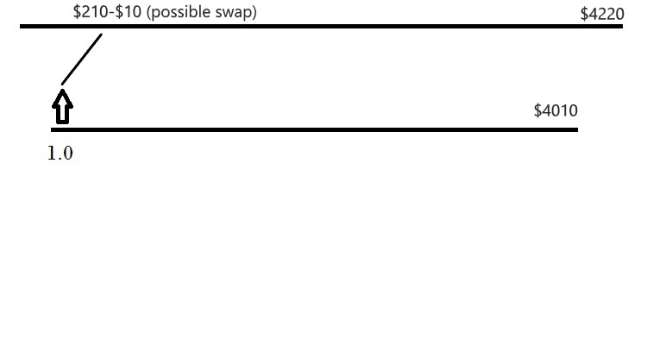
2. The other possible outcome is the price to reverse after we buy. If it does, we sell at the level of $3940. This is $70 lower or 1/3 of the initial $210 Profit distance. And we place the same $210 as a Take Profit for the short trade. This would be $3730.
So how much do we sell?
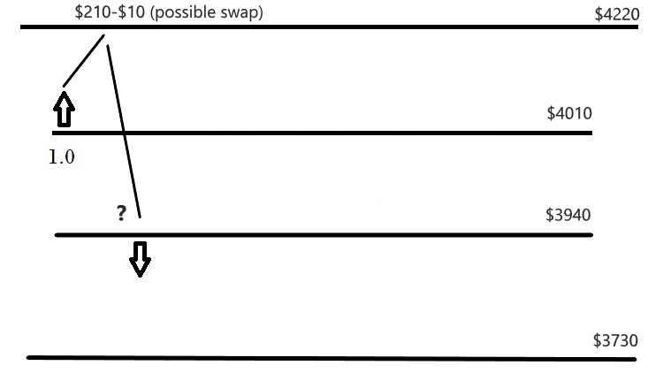
3. After the sell we have 2 outcomes again:
- The price reaches $3730. In this case, from the first trade, we will have a negative of $280 = $4010 - $3730. The question is How much we have to sell to cover this loss?
Or in other words: If the price reaches $3730 what profit we need to have from the second trade to cover the -$280 loss from the first trade?

Now let’s grab the calculator…

- sell 1.1 lots -> the profit would be 1.1 x $210 - $11cost = $220…not enough
- sell 1.2 lots -> the profit would be 1.2 x $210 - $12cost = $240…not enough
- sell 1.3 lots -> the profit would be 1.3 x $210 - $13cost = $260…not enough
- sell 1.4 lots -> the profit would be 1.4 x $210 - $14cost = $280…exactly!

We need to sell 1.4 lots which will cover the loss from the first trade:
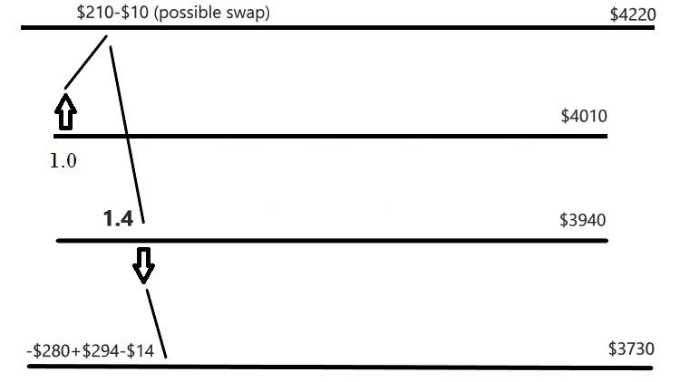
This means that for the first trade we will have Take Profit at $4220 and a Stop Loss at $3730. And for the second 1.4 short trade, we will have Take Profit at $3730 and a Stop Loss at $4220.
- If the price does not reach $3730 and goes up again, at $4010 we will buy again.
How much we will buy to cover the loss from selling 1.4 lots at $3940?
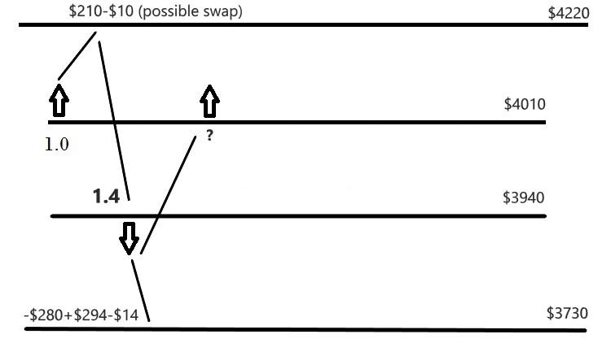
At $4220 we will have $210-$10 from the first long trade
and negative of 1.4 x $280 = -$392 from the second short trade.

Totally $210-$10-$392 = -$192 loss if the price reaches $4220. So how much do we need to buy at $4010? I think here it is obvious. If we buy another 1 lot it will cover this loss:

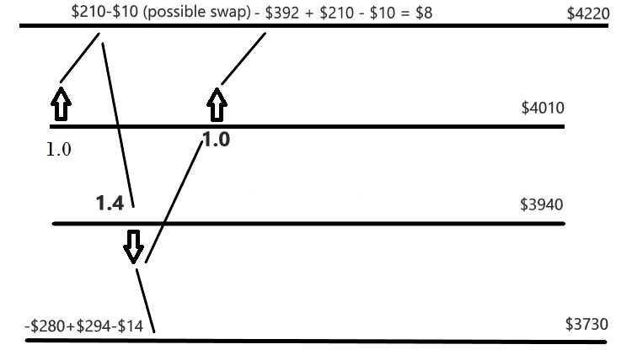

We will have $8 left as a profit if the price reaches $4220.

To calculate the next lots you need to follow the same logic and ask yourself the question: How much is needed to cover the loss from the last trade opened?

Regards,
Petko A

