BONUS Lecture: Continue To Learn
Section 10, Lecture 51

Special Offer for my existing students - $10 for any of my courses. Just click the link below in case you are interested or use coupon code "YOUR10":

Video Editing Masterclass With Cyberlink PowerDirector 15
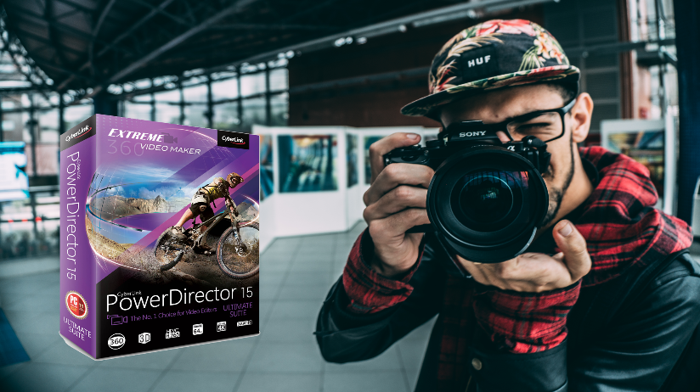
The Complete Video Editing Course With Wondershare Filmora


Creative Photo Editing Masterclass With Adobe Lightroom CC


The Complete Video Editing Course With Camtasia Studio 9


Canva Graphics Design Essential Training For Everyone


Create Amazing Images, Videos & Web Stories With Adobe Spark
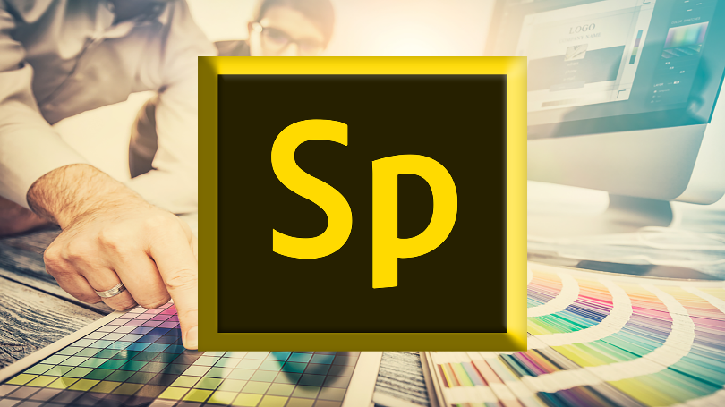

The Complete Video Editing Course With Sony Vegas Pro


Create Amazing Whiteboard Animation With Sparkol VideoScribe


The Complete Video Editing Course With Apple Final Cut Pro X


Create Professional Looking Infographics With No Experience


Bestselling T-shirt Design Masterclass With Adobe Photoshop
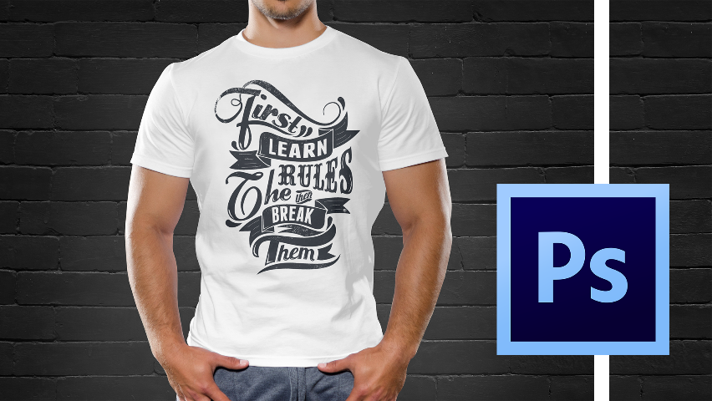

Bestselling T-shirt Design Mastery With Adobe Illustrator
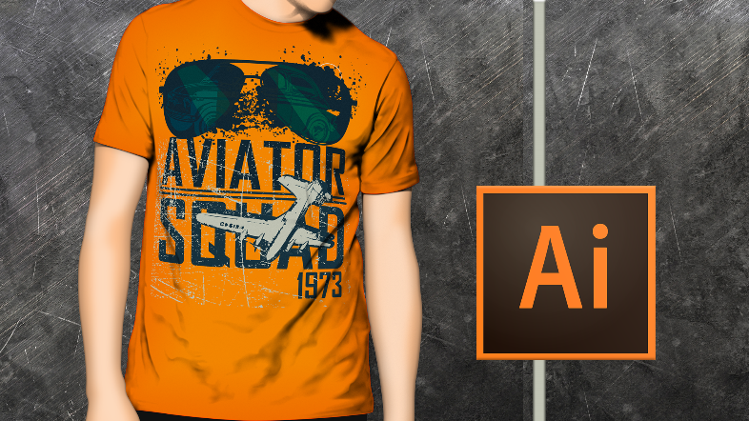

Adobe Photoshop For Everyone: Design 12 Practical Projects
