The Truth? I Need Your Review
Section 10, Lecture 50
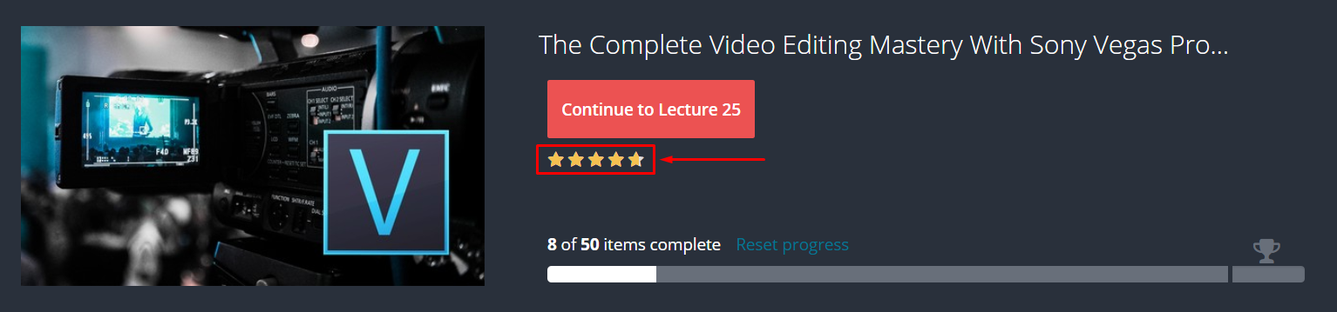
If you enjoy our course content then please LEAVE A 5 STARS REVIEW. It really helps us a lot to take this course into the next level.

